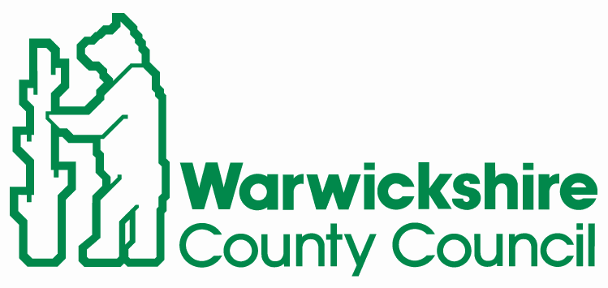

**Communities Group**

Monica Fogarty

Strategic Director for Communities

PO Box 43

Shire Hall

Warwick

CV34 4SX

[www.warwickshire.gov.uk](http://www.warwickshire.gov.uk)

W

WCC Ref: KC/LN

Dear Parent/Carer,

**FREE Road Safety Superheroes Resource**

We hope that you, your children and your families are staying safe and well.

Due to the ongoing pandemic Warwickshire Road Safety Club has been unable to visit your child’s class this term to deliver road safety education. In response to this, and to ensure your child receives vital road safety input, we have developed an online resource for children to access from home. This ‘Road Safety Superhero’ themed resource is made up of four bite-size videos and has been designed to be fun, engaging and informative.

This resource comprises four short videos and can be accessed via the following links:

***Video 1: Challenge #1 – Road Safety Super Code***

<https://youtu.be/4tlDzkTHhjA>

***Video 2: Challenge #2 – Superhero Safety Sorting***

<https://youtu.be/C9fU2NmTBUQ>

***Video 3: Challenge #3 – Tricky Crossing Tools***

<https://youtu.be/elrOmgiCbkM>

***Video 4: Challenge #4 – Design a Road Safety Superhero***

<https://youtu.be/hCsmEFotG7Y>

As each video session follows on from the one before, your child/ren will get the best learning experience if the sessions are followed in order. Please supervise your child whilst using YouTube to access resource.

For further information regarding road safety or support accessing these resources please contact: [roadsafetyeducation@warwickshire.gov.uk](mailto:roadsafetyeducation@warwickshire.gov.uk)

Thank you for your continued support, we hope you and your families have a lovely summer.

Kindest regards

Kate Castle and Louise Newham

Road Safety Officers, Warwickshire Road Safety Club